LAB ACTION PLAN FOR WEEK 2
Objective:
- Pushing multi-folder project into private repository (by student).
- Students must explore all listed git commands on the multi-folder project in local and remote repository.
- Students must explore all git commands on given scenario-based question.
- Students need to make note in observation book and also upload the executed exercise on scenario-based question.
Task 1: Pushing multi-folder project into private repository( Note: student take screenshots for upload).

1. Create a Private Repository on GitHub
- Go to https://github.com
- Click New repository
- Give it a name
- Check Private
- Click Create repository
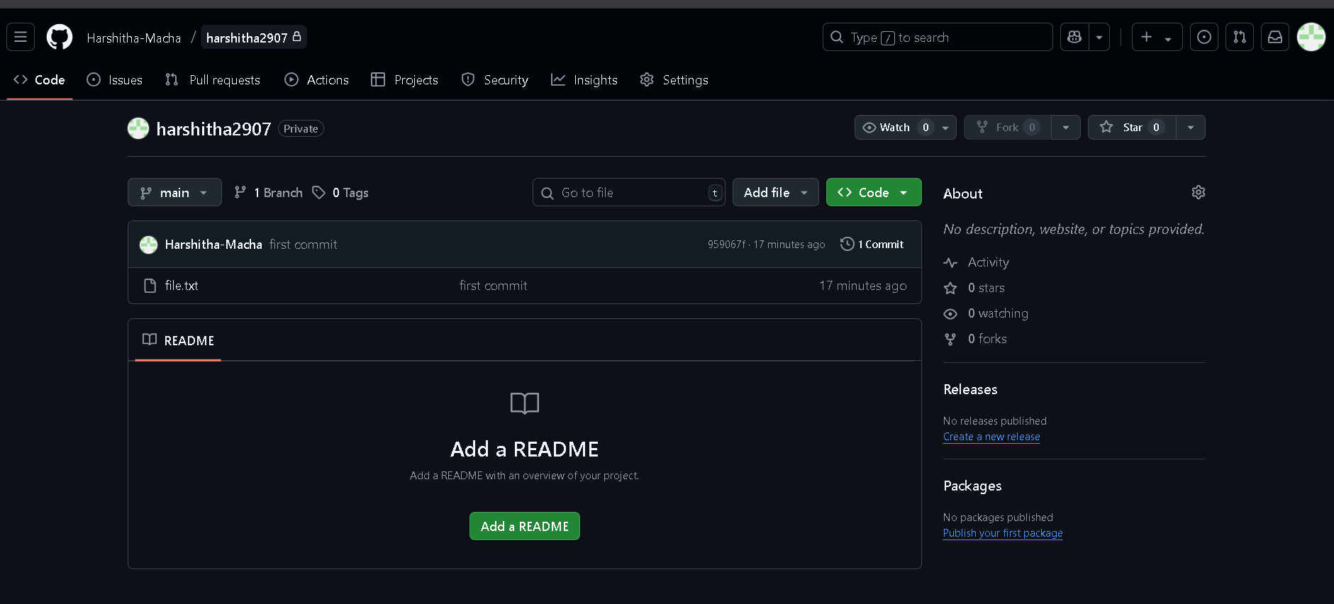
2. Initialize Git in Your Local Project (if not already done)
Open a terminal in the root of your multi-folder project:
cd /path/to/your/project
git init
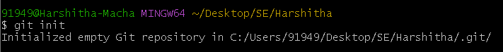

3. Add the Remote Repository (in bash)
You’ll see a URL on GitHub after creating the repo. It will look as below , run this command in git bash:
git remote add origin https://github.com/yourusername/your-private-repo.git

4. Add and Commit Your Files(in bash)
git add .
git commit -m "Initial commit"
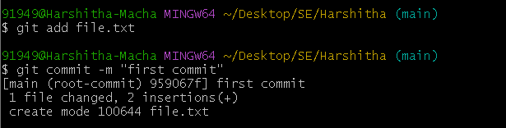
5. Push to the Private Repository
If the repo is new and empty, push like this from git bash:
git push -u origin master
If you're using the main branch (GitHub default):
git push -u origin main
You may be prompted to log in (via username/password or token).
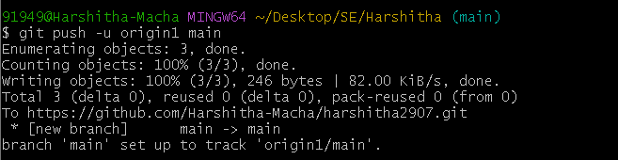

Task 3: Students must explore all git commands on given scenario-based question. (Note student write command in observation book and paste the answer (git command) below each question for uploading).

Scenario based questions on basic git commands
- You made changes to one file in the above project but haven’t staged them yet. You realize they were a mistake. What Git command will you use to discard the local changes?

Ans)

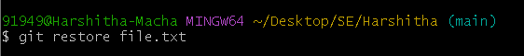
- You accidentally ran git add file1.txt (note instead of file.txt consider one file from above project), but you’re not ready to commit yet. How do you remove it from the staging area without losing the changes?

Ans) 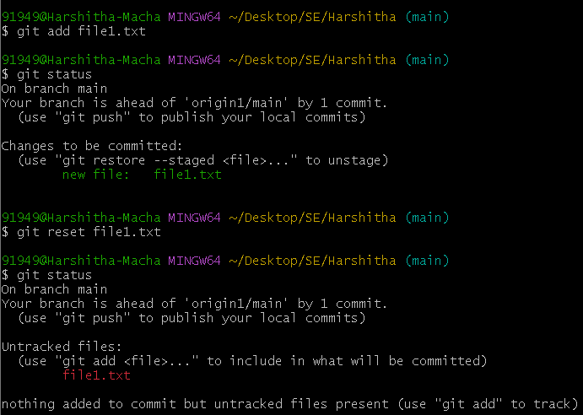

- You made a commit but typed the wrong commit message. You haven’t pushed it yet. How do you fix it?

Ans) 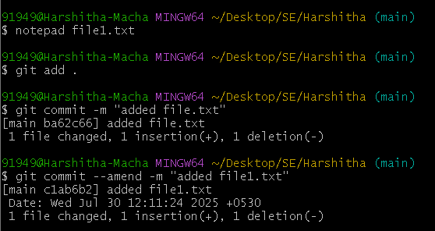
- You want to view the commit history of the current branch in a readable format. What Git command should you use?

Ans) 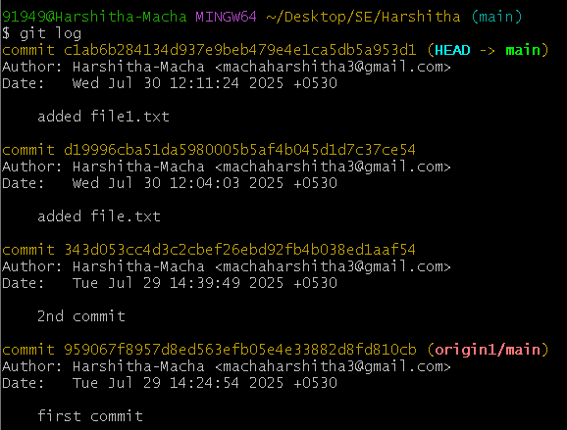

5. After cloning a repo, how can you set your name and email globally for all Git repositories?

Ans) 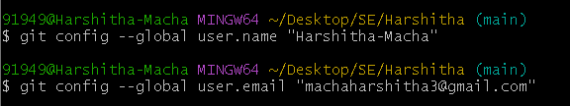

6.You’ve made some edits to your files but haven’t staged them. How can you view the changes?

Ans) 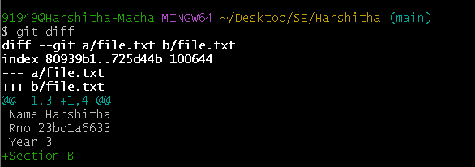

7.You’re on the main branch but need to switch to feature/login. What command do you use?

Ans) 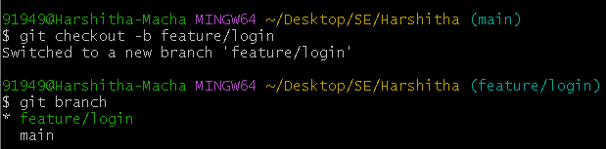

8.You deleted the feature-ui branch by mistake. You haven’t pushed the deletion. How ?

Ans)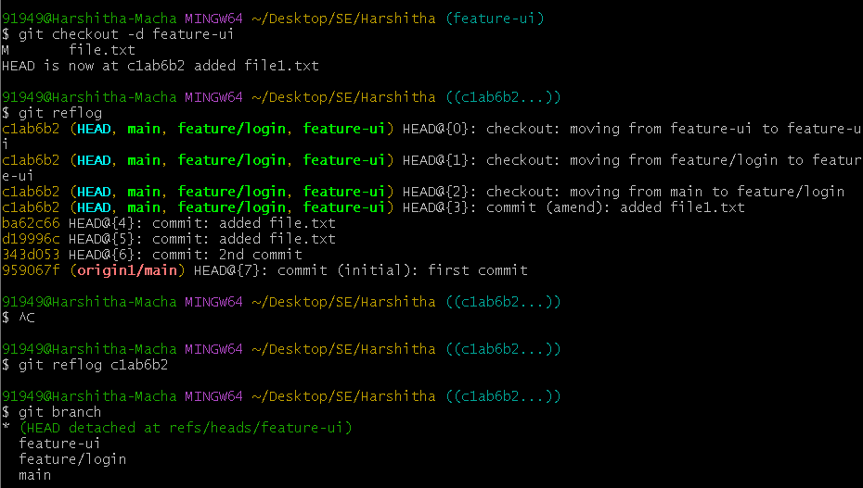
- You’ve made some commits locally and now want to upload them to the remote repository. What do you run?

Ans)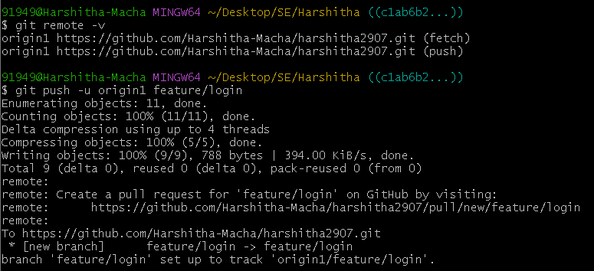
- How can you fetch the latest changes from the remote repository without merging them automatically?

Ans)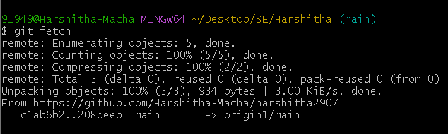
- You’re on the main branch and want to start working on a new feature called search-filter. What command do you use?

Ans)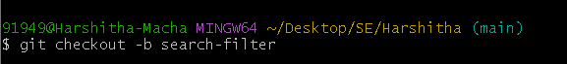
- You committed a file containing an API key and want to completely remove it from the repo's history. What should you do?

Ans)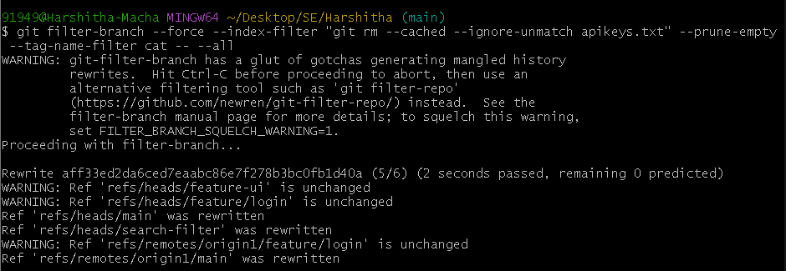
- You want to see all the branches that exist both locally and on the remote. What command?

Ans)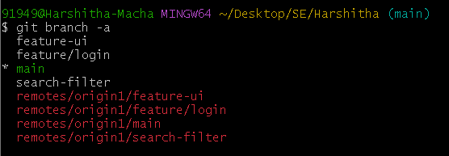
- You’re on main and want to merge the completed feature/signup branch into it. What command do you use?

Ans)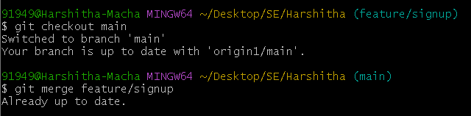
- You tried to merge two branches and Git reported a conflict in app.js. What are the general steps to resolve it?

Ans) Open conflicted file(file.txt)

Edit and remove conflict markers(<<<<<<<,======,>>>>>>)

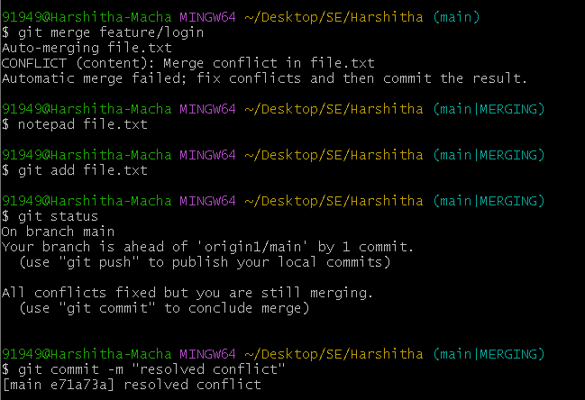
- You don’t want Git to track changes to .log files or node_modules/. How do you achieve this?

Ans)Add to .gitignore

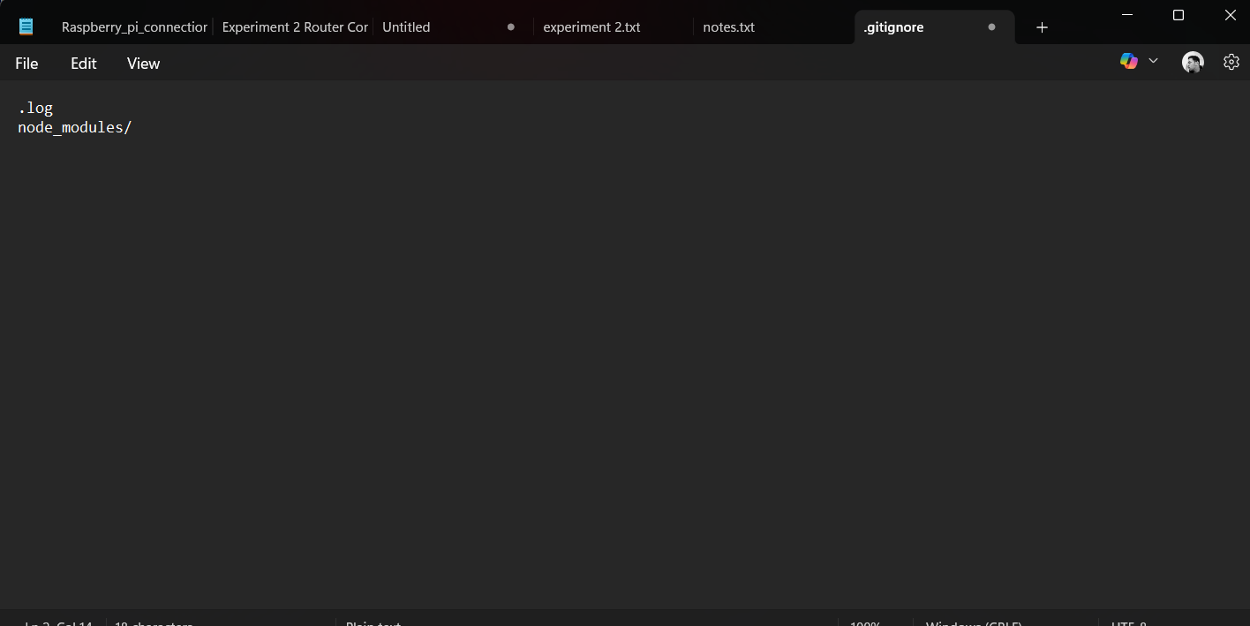
- You're investigating a bug and want to know who last changed line 25 in script.py. What command do you use?

Ans)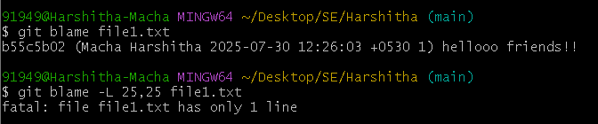
- You’re in the middle of working on a file but need to switch branches quickly. What do you do to save your work?

Ans)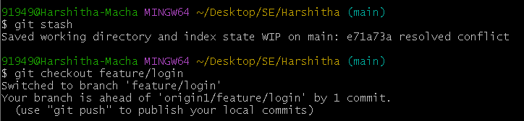
- You previously ran git stash and now want to restore those changes. What command do you use?

Ans)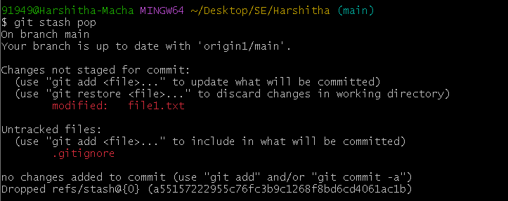
- The feature/test branch is no longer needed. How do you delete it locally?

Ans)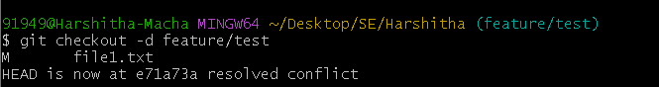
- You just merged the feature-ui branch into main. You want to clean up your local branches. How do you safely delete feature-ui?
Ans)
- You created a branch feature-experiment, made some changes, but now realize the code is no longer needed. You want to delete it, even though it hasn’t been merged. What command will you use?
Ans)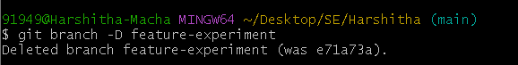
- You're currently on the feature-login branch and want to delete feature-ui. What must you ensure before running the delete command?
Ans)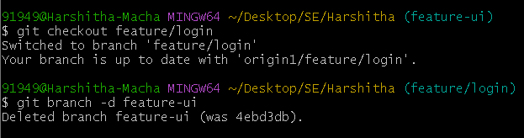
- You want to delete bugfix-footer, but you're unsure if it's been merged. What should you do before deleting it?
Ans)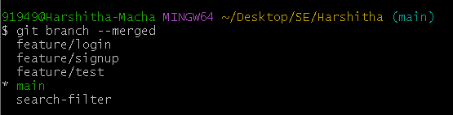
25. You finished working on feature-a, feature-b, and feature-c. All have been merged into main. How do you delete them in one command?
Ans)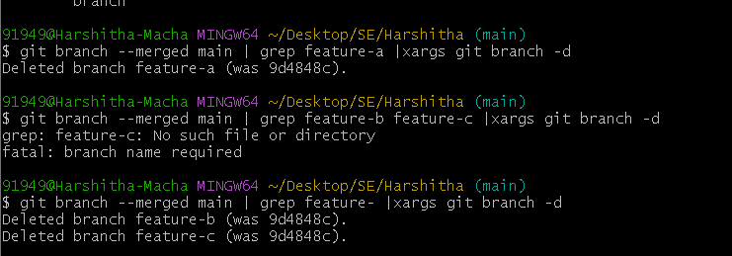
Scenario based questions on working with remote repository using Git commands

Specify the git command when you're starting work on a project and need to clone a remote repository to your local machine.

Ans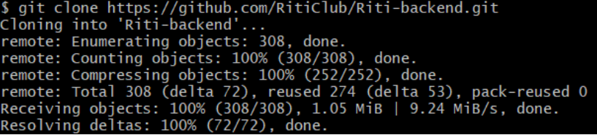

Specify the git command if you want to see the remotes that are connected to your local repository.

Ans)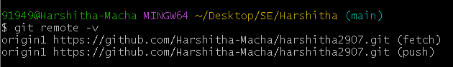

Specify the git command if you want to add a new remote repository to your local repository.

Ans)

Specify the git command to remove a remote repository from your local configuration:

Ans)

Specify the git command if you want to rename an existing remote:

Ans)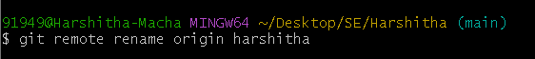

Specify the git command to fetch updates from the remote repository but not merge them into your local branch.

Ans)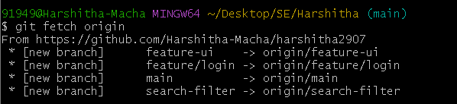

Specify the git command to pull the latest changes from the remote repository and merge them into your local branch.

Ans)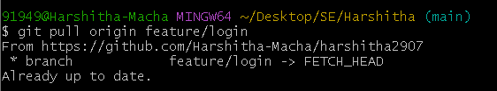

Specify the git command to push your local commits to a remote repository.

Ans)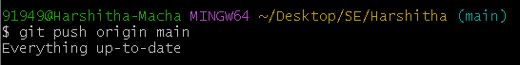

Specify the git command to when pushing for the first time and want to set the remote branch you are pushing to.

Ans) 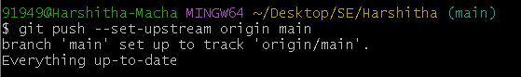

Specify the git command to change the URL of a remote (e.g., after changing the remote repository address).

Ans)

Specify the git command if you want to list all branches on the remote repository.

Ans)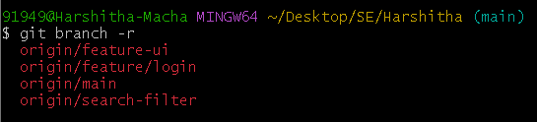

Specify the git command if a branch was deleted on the remote but still shows up locally.

Ans)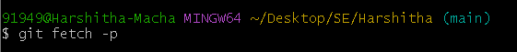

Specify the git command to fetch a specific branch from a remote.

Ans)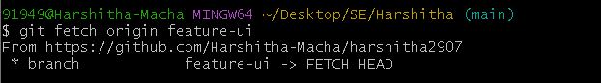

Specify the git command if you want to see detailed information about a remote repository.

Ans)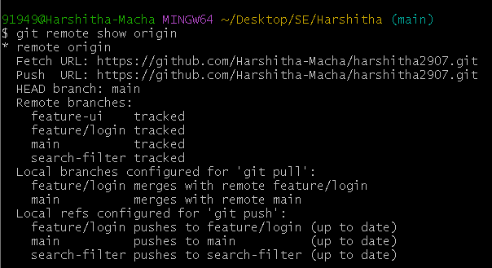

Specify the git command if you want to rebase your local branch onto a remote branch (this can be useful to keep your history linear)

Ans)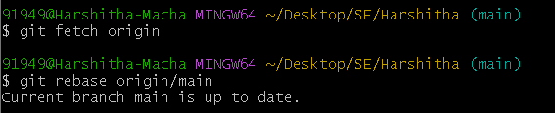

Conclusion:
Successfully uploading a multi-folder project to both public and private GitHub repositories demonstrates student’s practical understanding of core Git commands and remote repository management. By handling diverse file types (e.g., images, Java files, web pages, and pom.xml) and pushing them to different remote repositories, students show proficiency in:
- Initializing and configuring Git repositories
- Staging, committing, and managing version history
- Connecting to and working with multiple remote repositories
- Handling Gitignore and tracking large files appropriately
- Applying best practices for public vs. private repository usage
Completing these tasks equips students with essential version control skills and the ability to collaborate securely and professionally. It also reflects their readiness to contribute effectively to real-world software projects where source code management, team coordination, and secure code sharing are vital.

